**PCB Errors**

T02

Cameron Tribe, Jaime Rodrigez, Travis Berger, Sean Koppenhafer

### November 14th, 2014

### Version 1

|  |  |  |
| --- | --- | --- |
| Name: | Date: | Version: |
| Cameron Tribe | Nov. 14, 2014 | 1 |
|  |  |  |

# Error 1:

The first encountered error on the PCB was the pin connections of D4, the “dual reverse protection diode” IC. We assume this came from when the eagle schematic symbol was connected to the footprint.

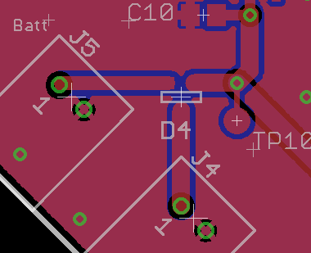 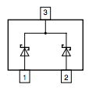

PCB Connections From Datasheet

To fix this error we have simply rotated the part, so that pin 1 is connected to J5-1 and pin 2 is connected to J4-1.

# Error 2:

The next error was found during the construction of the button de-bounce section. The tactile switches have the pin connection shown in the bottom left figure, and the figure to the right is our PCB connections. The buttons have essentially been shorted to ground since the part was created incorrectly. We assume that the incorrect connections came from then the schematic symbol and the footprint were connected.

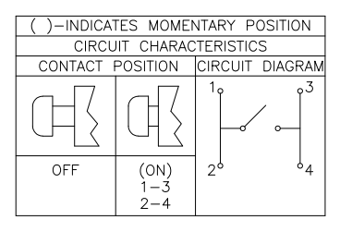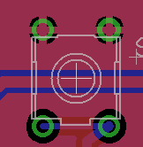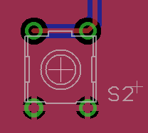

Datasheet Switch 1 Switch 2

To fix this, we will cut off pins 2 and 3 from Switch 1 and pins 1 and 4 from switch 2. This will remove the short and allow us avoid cutting traces.